Reflektion Integration

*Version 20.1.0*



Table of Contents

1. Summary 3

2. Component Overview 3

Functional Overview 3

Use Cases 4

Limitations, Constraints 5

Compatibility 5

Privacy, Payment 5

3. Implementation Guide 6

Setup of Business Manager 6

Configuration 7

Custom Code 10

External Interfaces 16

Firewall Requirements 16

4. Testing 17

5. Operations, Maintenance 19

Data Storage 19

Availability 19

Support 19

6. User Guide 20

Roles, Responsibilities 20

Business Manager 20

Storefront Functionality 21

7. Known Issues 24

8. Release History 24

# Summary

This document outlines the steps to implement the Reflektion LINK cartridge in SFRA and SGJC.

Reflektion's AI-powered personalization platform listens to the behaviors of each individual shopper, utilizes artificial intelligence to calculate their preferences and intent, and then responds to every moment-to-moment interaction by displaying the most relevant content and products in real time and across the digital touchpoints that matter most—including preview and site search, product recommendations, content personalization, category and landing pages, and email.

The Reflektion LINK cartridge provides product search suggestions, search results, and recommendations based on the current shopper’s behavior in real-time.

# **Component Overview**

## Functional Overview

This cartridge includes:

* Beacon script
* Product feed export job
* Category feed export job
* Frontend widgets
  + Preview search
  + Full page search
  + Recommendations
    - Homepage
    - Category - Product Landing Page (PLP)
    - Product Detail Page (PDP) - 2 widgets
    - Cart page
    - No search results page
* Event reporting
* Variation group support
* Multiple site support
* Multiple language support
* *FUTURE USE: Multiple currency support*

## Use Cases

**Product feed export job**

ReflektionProductFeedExport exports all the products in the site catalog to a CSV file and uploads it to the Reflektion SFTP server. Variation masters, variation groups, and variants are included in the product feed.

The Product feed export job can be configured to include product custom attributes.

1. Default custom attributes are specified in the “Reflektion Custom Attributes” site preference.
2. Localized custom attributes are specified in the “Reflektion Localized Custom Attributes” site preference.

The Product feed export job supports multiple locales.

1. All locales configured for the site will be included by default in the product feed.
2. Specific locales can be excluded by configuring the “Reflektion Exclude Locales” site preference.
3. Each locale should have a currency associated with it in the “Reflektion Currency Map” site preference. Currently only a single currency is supported across locales in a single site. Multiple currencies will be supported in the future.

**Category feed export job**

ReflektionCategoryFeedExport exports all the categories in the site storefront catalog to a CSV file and uploads it to the Reflektion SFTP server.

The Category feed export job will exclude the locales specified in the “Reflektion Exclude Locales” site preference.

**Frontend widgets**

The frontend widgets render personalized products for the current shopper.

1. The preview search widget returns search suggestions based on the search phrase entered in the search box.
2. The full page search widget returns the search results when a search is executed.
3. The recommendation widgets display recommended products on the following pages:
   * Homepage
   * Category - Product Landing Page (PLP)
   * Product Detail Page (PDP) - 2 widgets
   * Cart page
   * No search results page

**Event reporting**

The following events are reported to Reflektion for personalization and analytics:

1. Product added to cart
2. Cart status
3. Login
4. Order confirmation

**Multiple sites and locales**

The cartridge supports multiple SFCC sites and locales.

If your SFCC implementation has multiple sites, each site will need to:

1. Configure the unique “Reflektion Customer Key” site preference.
2. Create a new site-specific service credential. reflektion.sftp.<SITE ID>, with the unique Reflektion SFTP hostname and credentials.
3. Configure the “Reflektion Filename Prefix” site preference to be unique for each site.
4. Send a product feed to Reflektion. Update the Product feed export job scope to include all the sites.
5. Send a category feed to Reflektion. Update the Category feed export job scope to include all the sites.
6. Configure the “Reflektion Localized Custom Attributes” with the product custom attributes to include for all non-default locales.
7. Configure the “Reflektion Exclude Locales” site preference with locales to exclude. See the Configuration section for more information.
8. Configure the “Reflektion Currency Map” site preference with currency for each locale. Currently only a single currency can be specified for all locales. In future, multiple currencies will be supported. See the Configuration section for more information.

## Limitations, Constraints

Access to the Reflektion UAT and Production Customer Engagement Console (CEC) is needed to implement this cartridge.

The Reflektion Customer Key and SFTP server information/credentials are available in the Production CEC.

Before frontend widget are rendered:

1. The widget RFK IDs used in SFCC must match those configured in the Reflektion CEC.
2. The product and category data feeds must be uploaded to Reflektion.
3. After product and category data feeds have been uploaded, Reflektion will need to verify the product and category data feeds and then schedule the corresponding import processes.
4. The widgets must be configured in the Reflektion CEC.
5. Reflektion needs to onboard those features before the widgets will be displayed.

Currently only a single currency is supported within a Reflektion customer instance, but multiple currency support is on the Reflektion roadmap for a future release. If multiple currencies are needed for a single site, please discuss further with the Reflektion team.

## Compatibility

Built on Commerce Cloud 19.10 (Compatibility mode 18.10), SFRA 4.2.1, and SiteGenesis 104.1.3

## Privacy, Payment

When a customer logs in, the user login event sends the customer’s first name, last name, and email to Reflektion.

Payment data is not being used by this integration.

# Implementation Guide

## Setup of Business Manager

**Add cartridges.**

1. Unzip the reflection cartridge zip archive.
2. Copy the cartridges into your project:

* For SFRA: int_reflektion, int_reflektion_sfra
* For SGJC: int_reflektion, int_reflektion_controllers

1. Go to your project.
2. Import the Reflektion cartridges in your project.
3. Upload the cartridges to the sandbox.

**Storefront cartridge path updates.**

1. Go to the Business Manager.
2. Go to Administration > Sites > Manage Sites.
3. Select your site.
4. Click on the “Settings” tab.
5. Add the Reflektion cartridges to the “Cartridges” field:

* For SFRA, add int_reflektion_sfra:int_reflektion: at the beginning of the path.
* For SGJC, add :int_reflektion_controllers:int_reflektion at the end of the path.

1. Click the "Apply" button.

**Business Manager Cartridge path updates.**

1. Go to the Business Manager.
2. Go to Administration > Sites > Manage Sites.
3. Click on “Business Manager” site.
4. Add int_reflektion: to beginning of the “Cartridges” field.
5. Click the "Apply" button.

**Import metadata, services, and jobs.**

Use the Site Import to add the following:

* Reflektion site preferences
* reflektion.sftp service and service credentials for SFRA and SGJC reference sites
* ReflektionProductFeedExport and ReflektionCategoryFeedExport jobs

1. Go to the Business Manager.
2. Go to Administration > Site Development > Site Import & Export.
3. Under “Import”.
4. Click the “Choose File” button.
5. Select metadata/reflektion-data.zip from the cartridge zip.
6. Click the “Upload” button.
7. Select the radio button next to “reflektion-data.zip”.
8. Click the “Import” button.
9. Next to “Are you sure that you want to import the selected archive?”, click the “OK” button.
10. Under “Status”, monitor the Site Import process and confirm that it completes successfully.

## Configuration

**SFRA client-side JavaScript**

Update your SFRA project builder to include int_reflektion_sfra so that /int_reflektion_sfra/cartridge/client/default/js/reflektion.js is built as part of your storefront cartridge.

**Services**

By default, service credentials are created for the SFRA and SGJC reference applications.

Add a new service credential for your site. If there are multiple sites, create a new service credential for each site.

1. Go to the Business Manager.
2. Go to Administration > Operations > Services.
3. Click the “Credentials” tab.
4. Click “New”.
5. Enter Name: reflection.sftp.<SFCC SITE ID>.
6. Enter URL: Reflektion SFTP hostname.
7. Enter User: Reflektion SFTP user.
8. Enter Password: Reflektion SFTP password
9. Click “Apply”.

**Jobs**

Configure the Product feed export job to run for your site.

1. Go to the Business Manager.
2. Go to Administration > Operations > Jobs.
3. Select the ReflektionProductFeedExport job.
4. Click on the "Job Steps" tab.
5. Click on the value next to "Scope" label.
6. Select your site.
7. Click "Assign".

Configure the Category feed export job to run for your site.

1. Go to the Business Manager.
2. Go to Administration > Operations > Jobs.
3. Select the ReflektionCategoryFeedExport job.
4. Click on the "Job Steps" tab.
5. Click on the value next to "Scope" label.
6. Select your site.
7. Click "Assign".

**Site preferences**

1. Go to the Business Manager.
2. Go to Merchant Tools > Site Preferences > Custom Preferences.
3. Click “Reflektion”.
4. Set the preference values:

|  |  |
| --- | --- |
| **Name** | **Description/Value** |
| Reflektion Enabled | Enable Reflektion site functionality and exports.  Set to Yes. |
| Reflektion Filename Prefix | The filename prefix used for the product and category feeds.  Must be unique per site.  Set to the SFCC Site ID. |
| Reflektion Feed Export Path | SFCC path under IMPEX to export product and category feeds.  Leave empty to use default “reflektion”. |
| Reflektion Feed Upload Path | Remote path on the Reflektion SFTP server to upload the product and category feeds to.  Leave empty to use default “upload”. |
| Reflektion Product Feed Image Type | Product Image Type to use for the Product Feed image_url in the product feed.  Example: small |
| Reflektion Product Feed Upload Enabled | Upload the product feed to the Reflektion SFTP server after it is exported.  Set to Yes. |
| Reflektion Category Feed Upload Enabled | Upload the category feed to the Reflektion SFTP server after it is exported.  Set to Yes. |
| Reflektion Environment | Reflektion environment to use.  Set to UAT for all non-Production environments.  Set to PROD for Production environment. |
| Reflektion Customer Key | Set to Customer Key from Reflektion. |
| Reflektion Simple Search rfkid | Set to Preview Search RFK ID from Reflektion.  Leave empty to suppress functionality. |
| Reflektion Full Page Search rfkid | Set to Full Page Search RFK ID from Reflektion.  Leave empty to suppress functionality. |
| Reflektion Home page Rec rfkid | Set to Home Page Recommendation Widget RFK ID from Reflektion.  Leave empty to suppress functionality. |
| Reflektion PDP rec rfkid | Set to PDP recommendation Widget RFK ID from Reflektion.  Leave empty to suppress functionality. |
| Reflektion PDP rec 2 rfkid | Set to PDP Recommendation 2 Widget RFK ID from Reflektion.  Leave empty to suppress functionality. |
| Reflektion Category rec rfkid | Set to Category Recommendation Widget RFK ID from Reflektion.  Leave empty to suppress functionality. |
| Reflektion Cart rec rfkid | Set to Cart Recommendation Widget RFK ID from Reflektion.  Leave empty to suppress functionality. |
| Reflektion No Search Results rec rfkid | Set to No Search Results Recommendation Widget RFK ID from Reflektion.  Leave empty to suppress functionality. |
| Reflektion Custom Attributes | Comma-delimited list of product custom attribute IDs to include in the product feed.  Leave empty to not include any custom attributes. |
| Reflektion Localized Custom Attributes | Comma-delimited list of product custom attribute IDs to include as localized fields in the product feed. Must be a subset of Reflektion Custom Attributes.  Leave empty to not include any localized custom attributes. |
| Reflektion Exclude Locales | Comma-delimited list of site locales to exclude from the product and category feeds.  Leave empty to not exclude any locales.  Example: default,en_US |
| Reflektion Currency Map | JSON configuration that maps locale code to currency code.  Reflektion currently only supports a single currency per product feed, so the same currency code must be configured for every locale.  Example 1:  {  "en_US": "USD"  }  Example 2:  {  "fr_FR": "EUR",  "it_IT": "EUR"  }  *FUTURE FEATURE: Multiple currency support.* |
| RFK UAT Beacon | Reflektion UAT Beacon Source URL.  The RFK_CUSTOMER_KEY placeholder will be replaced.  Leave empty to use default value: //initjs.uat.rfksrv.com/rfk/js/RFK_CUSTOMER_KEY/init.js |
| RFK PROD Beacon | Reflektion Production Beacon Source URL.  DOMAIN_HASH and RFK_CUSTOMER_KEY placeholders will be replaced.  Leave empty to use default value: https://DOMAIN_HASH-prod.rfksrv.com/rfk/js/RFK_CUSTOMER_KEY/init.js |

## Custom Code

**Product feed export job**

No changes are needed when used with the SFRA and SGJC reference applications. However, if customizations have been made to product attributes such as product image URLs those will also need to be applied to /int_reflektion/cartridge/scripts/jobs/reflektionProductFeedExport.js.

**SFRA**

No custom code is necessary as the cartridge overrides SFRA.

However if some of the updated ISML templates have been customized on your site, then the Reflektion changes will need to be merged into your existing templates. These are the ISML templates that are overridden in SFRA:

1. /int_reflektion_sfra/cartridge/templates/default/cart/cart.isml
2. /int_reflektion_sfra/cartridge/templates/default/checkout/confirmation/confirmation.isml
3. /int_reflektion_sfra/cartridge/templates/default/components/footer/pageFooter.isml
4. /int_reflektion_sfra/cartridge/templates/default/components/header/search.isml
5. /int_reflektion_sfra/cartridge/templates/default/home/homePage.isml
6. /int_reflektion_sfra/cartridge/templates/default/product/productDetails.isml
7. /int_reflektion_sfra/cartridge/templates/default/search/noResultsProduct.isml
8. /int_reflektion_sfra/cartridge/templates/default/search/searchResultsNoDecorator.isml

**SGJC: Client-side JavaScript**

Add this JavaScript:

if (typeof rfkDomain !== 'undefined') {

var isqv = $form.parents('#QuickViewDialog').length === 1;

var name = isqv ? 'qview' : 'pdp';

var pid = $form.find('input[name="pid"]').val();

var rfk = window.rfk = window.rfk || [];

rfk.push(["trackEvent", {

"type": "a2c",

"name": name,

"value": {

"products": [{

"sku": pid

}],

"dn": rfkDomain,

"locale": {

"lg": rfkLanguage,

"co": rfkCountry,

"cy": rfkCurrency

}

}

}]);

}

to your site’s js/pages/product/addToCart.js:

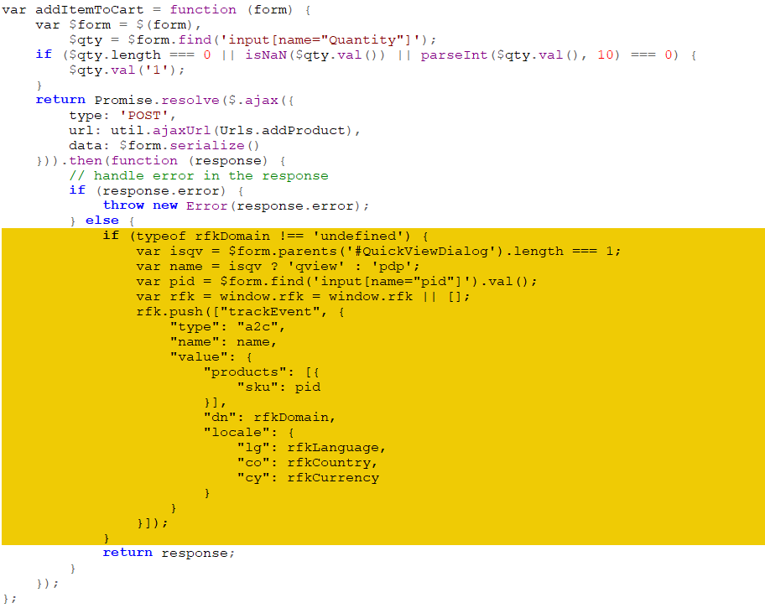

**SGJC: ISML templates**

Use the ISML templates in /int_reflektion_controllers/cartridge/templates/ for reference and copy the code snippets needed to update the same ISML templates in your site as follows:

/int_reflektion_controllers/cartridge/templates/default/checkout/cart/cart.isml

Apply code changes:

${require('*/cartridge/scripts/ReflektionHelper').getCartRec()}

<isif condition="${require('*/cartridge/scripts/ReflektionHelper').getRFKEnabled()}">

<isinclude template="reflektion/cartStatus"/>

</isif>

As shown:

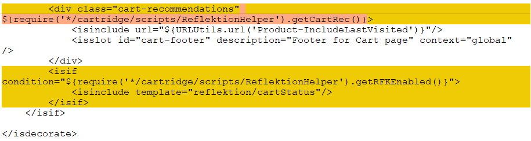

/int_reflektion_controllers/cartridge/templates/default/checkout/confirmation/confirmation.isml

Apply code changes:

<isif condition="${require('*/cartridge/scripts/ReflektionHelper').getRFKEnabled()}">

<isinclude template="reflektion/orderConfirmation"/>

</isif>

As shown:

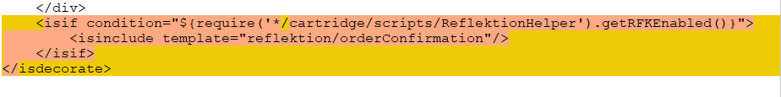

/int_reflektion_controllers/cartridge/templates/default/components/footer/footer.isml

Apply code changes:

<isinclude URL="${URLUtils.url('Reflektion-Beacon','pushCart', require('*/cartridge/scripts/ReflektionHelper').pushCart())}"/>

As shown:

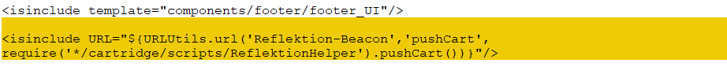

/int_reflektion_controllers/cartridge/templates/default/content/home/homepage.isml

Apply code changes:

<div class="recommendation" ${require('*/cartridge/scripts/ReflektionHelper').getHomepageRec()}></div>

As shown:

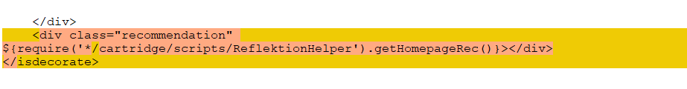

/int_reflektion_controllers/cartridge/templates/default/product/producttopcontent.isml

Apply code changes:

<isset name="rfkPDPRec" value="${require('*/cartridge/scripts/ReflektionHelper').getPDPRec()}" scope="page">

<isif condition="${recProducts.size() > 0 && empty(rfkPDPRec)}">

<div class="recommendations" ${rfkPDPRec}></div>

<div class="recommendations2" ${require('*/cartridge/scripts/ReflektionHelper').getPDPRec2()}></div>

As shown:

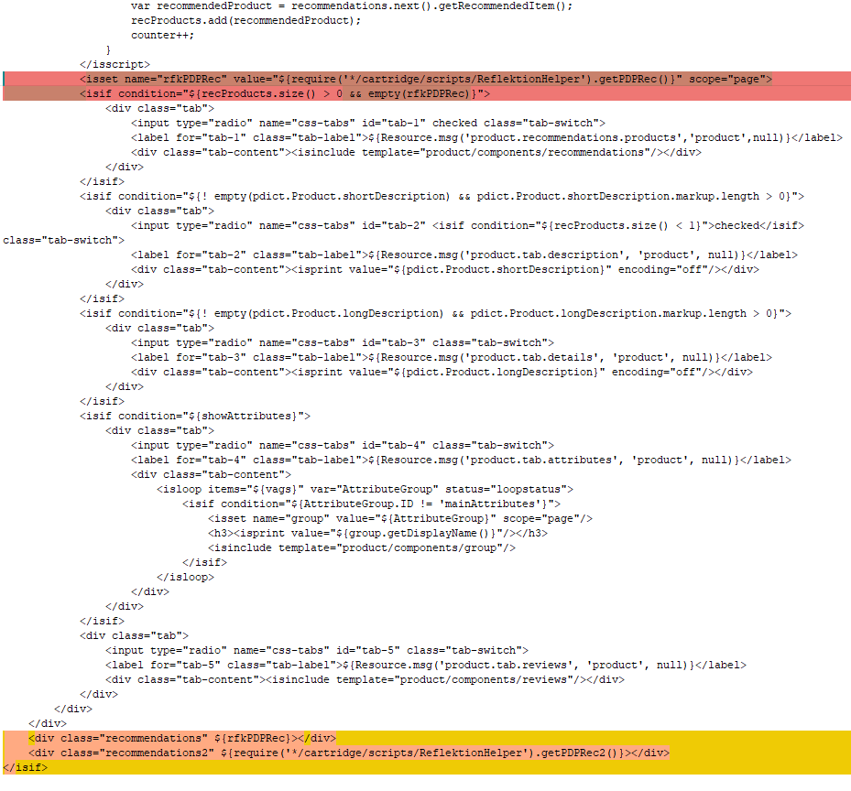

/int_reflektion_controllers/cartridge/templates/default/rendering/category/categoryproducthits.isml

Apply code changes:

<isif condition="${pdict.ProductSearchResult.category}">

<div class="recommendations" ${require('*/cartridge/scripts/ReflektionHelper').getCategoryRec()}></div>

</isif>

As shown: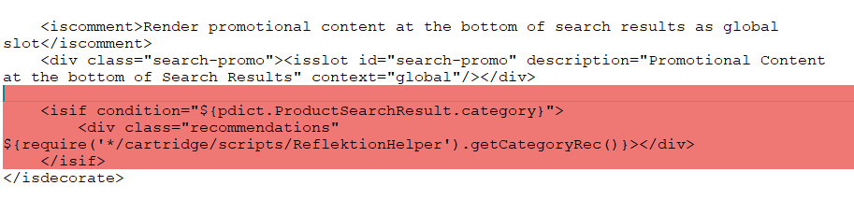

/int_reflektion_controllers/cartridge/templates/default/search/nohits.isml

Apply code changes:

<div class="recommendations" ${require('*/cartridge/scripts/ReflektionHelper').getNoSearchResultsRec()}></div>

As shown:

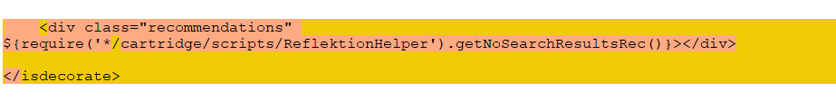

/int_reflektion_controllers/cartridge/templates/default/search/pt_productsearchresult.isml

Apply code changes:

<isset name="rfkFullPageSearch" value="${require('*/cartridge/scripts/ReflektionHelper').getFullPageSearch(pdict.CurrentHttpParameterMap.cgid.submitted && pdict.CurrentHttpParameterMap.cgid.value != '')}" scope="page">

<div id="main" role="main" class="clearfix" ${rfkFullPageSearch}>

<isif condition="${empty(rfkFullPageSearch)}">

<isinclude template="components/browsertoolscheck"/>

<isreplace/>

</isif>

</div>

As shown:

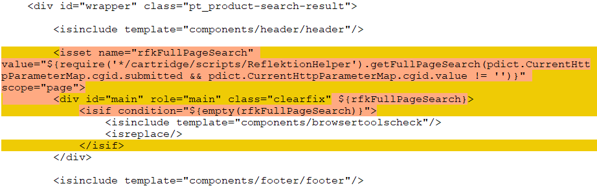

/int_reflektion_controllers/cartridge/templates/default/search/pt_productsearchresult_nohits.isml

Apply code changes:

<isset name="rfkFullPageSearch" value="${require('*/cartridge/scripts/ReflektionHelper').getFullPageSearch(false)}" scope="page">

<div id="main" role="main" class="page-content clearfix" ${rfkFullPageSearch}>

<isinclude template="components/browsertoolscheck"/>

<isif condition="${empty(rfkFullPageSearch)}">

<div id="primary" class="primary-content">

<isreplace/>

</div>

<div id="secondary">

<isinclude template="search/components/productsearchrefinebar"/>

</div>

</isif>

</div>

As shown:

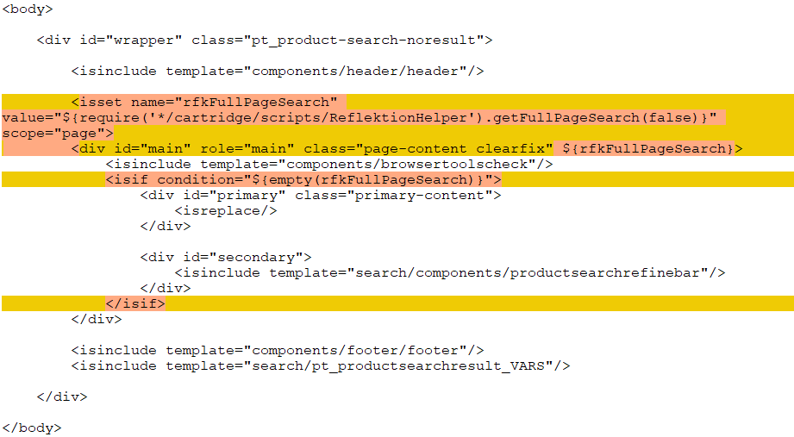

/int_reflektion_controllers/cartridge/templates/default/search/simplesearch.isml

Apply code changes:

<input type="text" id="q" name="q" value="" placeholder="${Resource.msg('simplesearch.searchtext', 'search', null)}" ${require('*/cartridge/scripts/ReflektionHelper').getSimpleSearch()}/>

As shown:

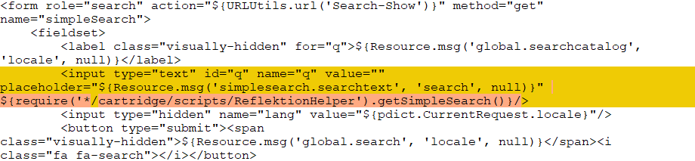

## External Interfaces

The Product feed export and Category feed export jobs upload CSV data files to the configured Reflektion SFTP server.

## Firewall Requirements

None.

# Testing

**Product feed export job**

1. Go to the Business Manager.
2. Go to Administration > Operations > Jobs.
3. Select the ReflektionProductFeedExport job.
4. Click “Run Now”.
5. Verify that the product feed is successfully exported by checking the product feed in /on/demandware.servlet/webdav/Sites/Impex/reflektion/Archive.  
   The product feed filename will be <REFLEKTION FILENAME PREFIX FROM SITE PREFS>_product_feed.csv
6. Verify the file was uploaded by using an SFTP client to access the Reflektion SFTP server and checking the /upload directory.

**Category feed export job**

1. Go to the Business Manager.
2. Go to Administration > Operations > Jobs.
3. Select the ReflektionCategoryFeedExport job.
4. Click “Run Now”.
5. Verify that the category feed is successfully exported by checking the category feed in /on/demandware.servlet/webdav/Sites/Impex/reflektion/Archive.  
   The category feed filename will be <REFLEKTION FILENAME PREFIX FROM SITE PREFS >_category_feed.csv
6. Verify the file was uploaded by using an SFTP client to access the Reflektion SFTP server and check the /upload directory.

**Preview search widget**

1. Go to the storefront.
2. Type a keyword in the search box in the global header.
3. When preview search is enabled, the Reflektion search suggestions will be displayed.

**Full page search widget**

1. Go to the storefront.
2. Type a keyword in the search box in the global header and press “Enter” to submit the form.
3. When full page search is enabled, the Reflektion search results will be displayed.

**Homepage recommendation widget**

1. Go to the storefront.
2. Go to the homepage.
3. When the homepage recommendation widget is enabled, the recommended products will be displayed just above the footer.

**PDP recommendation widgets (2)**

1. Go to the storefront.
2. Go to a PDP.
3. When PDP recommendation widgets are enabled, the recommended products will be displayed in two areas just above the footer.

**Category (Product Landing Page) recommendation widget**

1. Go to the storefront.
2. Go to a PLP.
3. When the category recommendation widget is enabled, the recommended products will be displayed just above the footer.

**Cart page recommendation widget**

1. Go to the storefront.
2. Go to a PDP.
3. Add the product to the cart.
4. Click on the cart icon in the global header.
5. When the cart recommendation widget is enabled, the recommended products will be displayed just above the footer.

**No search results page recommendation widget**

1. Go to the storefront.
2. Type “zxcvb” into the search box and press “Enter” submit the form.
3. When the no search results recommendation widget is enabled, the recommended products will be displayed just above the footer.

**Event reporting**

1. Go to the storefront.
2. Open the JavaScript console.
3. Enter “rfk.P._uid”. This is your Reflektion session UUID. Copy the value.
4. Go to the Reflektion UAT Customer Engagement Console.
5. Go to “Developer Resources” by clicking on “</>“ in the left navigation.
6. Click on the “Event Monitor” tab.
7. Paste the Reflektion session UUID into the UUID field.
8. Click “Start Monitoring”.
9. Go to storefront.
10. Browse the site and events will be logged in the Event Monitor when:
    * Product is added to cart.
    * Cart page is viewed.
    * Customer logs into My Account.
    * Order is submitted.

**Multiple sites/locales**

1. Go to the Business Manager.
2. Go to Merchant Tools > Site Preferences > Custom Preferences.
3. Click “Reflektion”.
4. Set the site preferences:
   * Reflektion Filename Prefix
   * Reflektion Localized Custom Attributes
   * Reflektion Exclude Locales
   * Reflektion Currency Map
5. Update Product feed export job scope to include your additional sites if needed.
6. Follow the steps to run Product feed export job.
7. Verify the product feed contains the columns for your site’s locales by checking the product feed in /on/demandware.servlet/webdav/Sites/Impex/reflektion/Archive.
8. Update Category feed export job scope to include your additional sites if needed.
9. Follow the steps to run Category feed export job.
10. Verify the category feed contains the columns for your site’s locales by checking the category feed in /on/demandware.servlet/webdav/Sites/Impex/reflektion/Archive.
11. Go to the storefront.
12. Follow the steps to test the widgets and verify the widgets are rendered in the correct language for your locale.
13. Follow the steps to test events and verify event data is reported correctly.

# Operations, Maintenance

## Data Storage

No data is stored in Salesforce Commerce Cloud.

## Availability

The Reflektion SFTP server has a 99.9% SLA. If the Reflektion SFTP server is not available, the Product feed export and Category feed export jobs would need to be re-run when the server is available again.

## Support

Please contact your Reflektion customer support team at [support@reflektion.com](mailto:support@reflektion.com) for product support questions.

# User Guide

## Roles, Responsibilities

The Product feed export and Category feed export jobs should be scheduled to run at least daily in Development/Staging and Production.

When the Reflektion cartridge is deployed to Production, the “Reflektion Environment” site preference must be set to PROD.

## Business Manager

**Jobs**

Two new jobs are added when reflektion-data.zip is imported.

1. ID: ReflektionProductFeedExport  
   Description: Export product data to CSV and uploads the file to Reflektion.  
   Schedule: At least daily. Update the schedule as needed by clicking the “Schedule and History” tab.  
   Scope: Click the “Job Steps” tab and click on “Sites Assigned” and select the sites the job should run for.
2. ID: ReflektionCategoryFeedExport  
   Description: Export category data to CSV and uploads the file to Reflektion.  
   Schedule: At least daily. Update the schedule as needed by clicking the “Schedule and History” tab.  
   Scope: Click the “Job Steps” tab and click on “Sites Assigned” and select the sites the job should run for.

**Site Preferences**

New Reflektion Site Preferences are added when reflektion-data.zip is imported. See the Configuration section for more information.

**Services**

New service and service credentials are added when reflektion-data.zip is imported:

1. A new SFTP service is added with ID: reflektion.sftp.
2. Sample reflektion.sftp.* service credentials are added for the SFRA and SGJC reference applications.

A new SFTP service credential must added for your site with service credential ID set to reflektion.sftp.<SITE ID>. See the Configuration section for more information.

## Storefront Functionality

**Preview search widget**

The preview search widget provides search suggestions based on the search phrase entered in the search box.

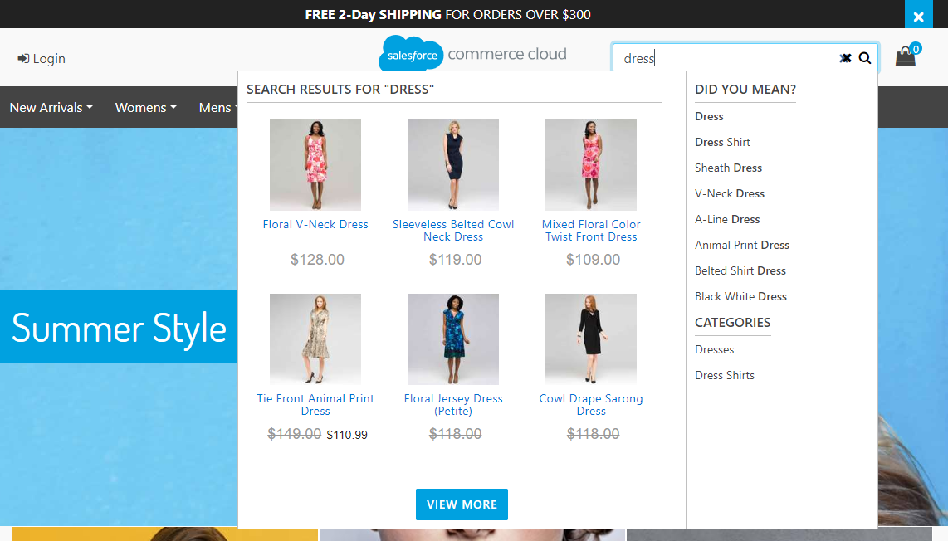

**Full page search widget**

The full page search widget provides the search results when a search is executed.

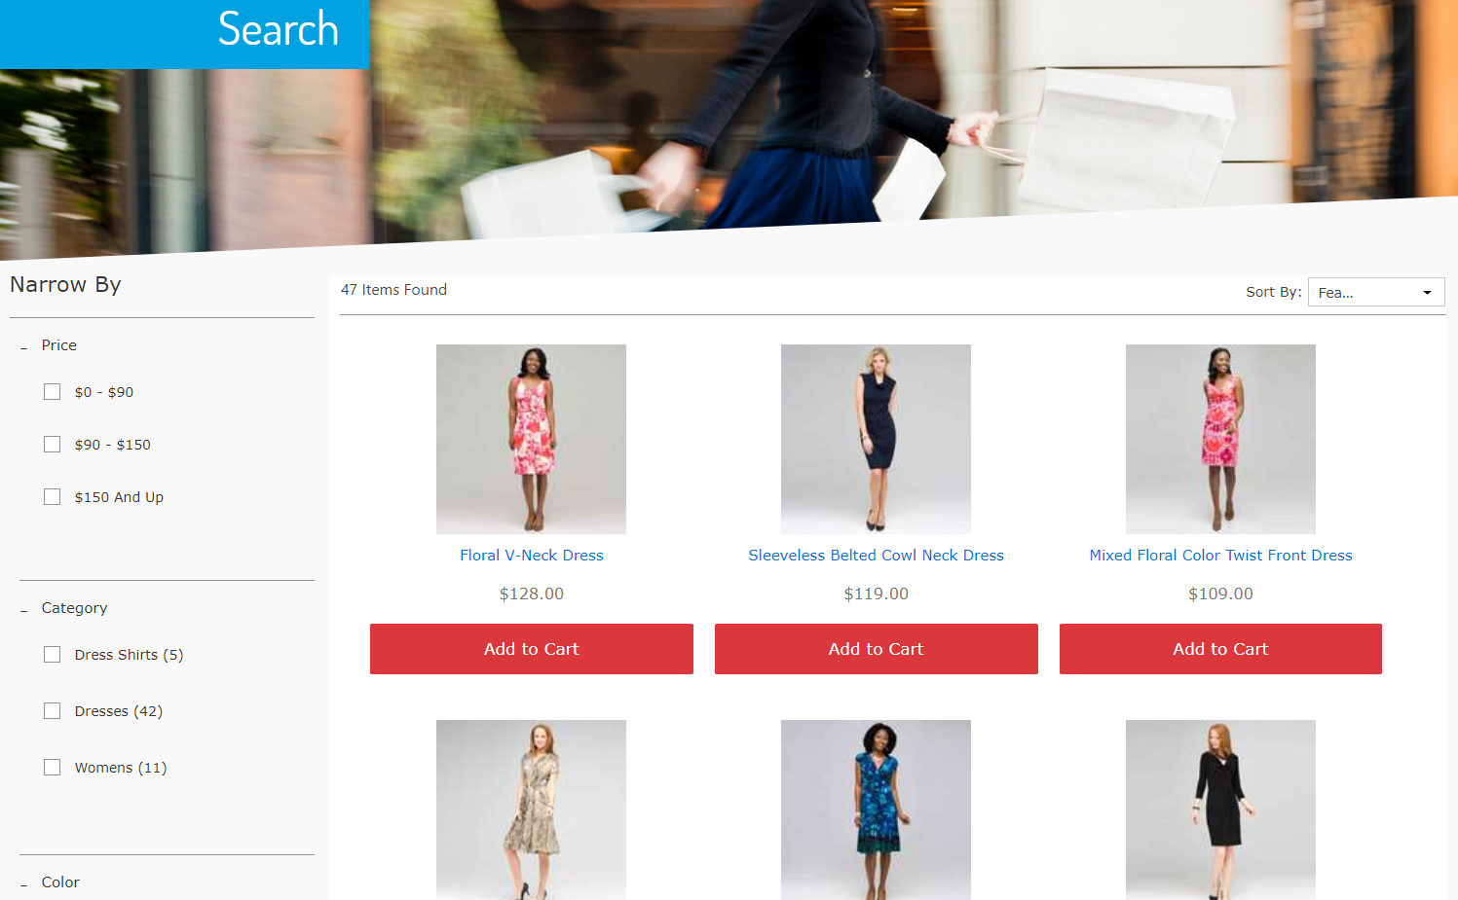

**Recommendation widgets**

The recommendation widgets display recommended products.

Homepage recommendation widget

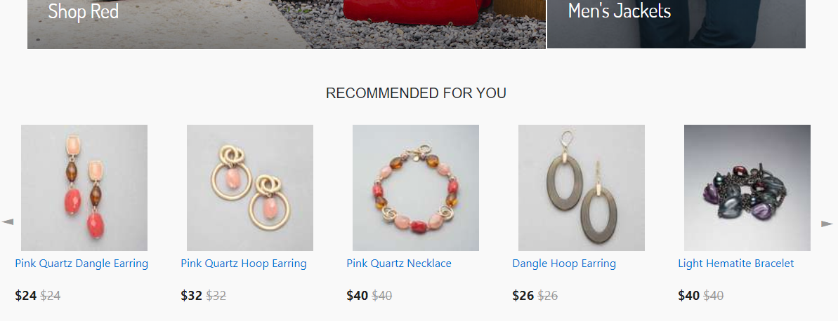

Product Detail Page (PDP) recommendation widgets

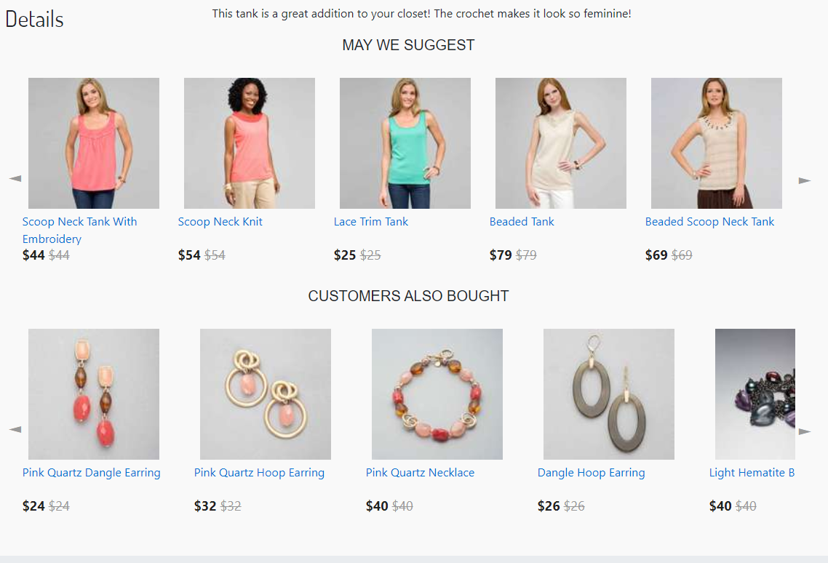

Category - Product Landing Page (PLP) recommendation widget

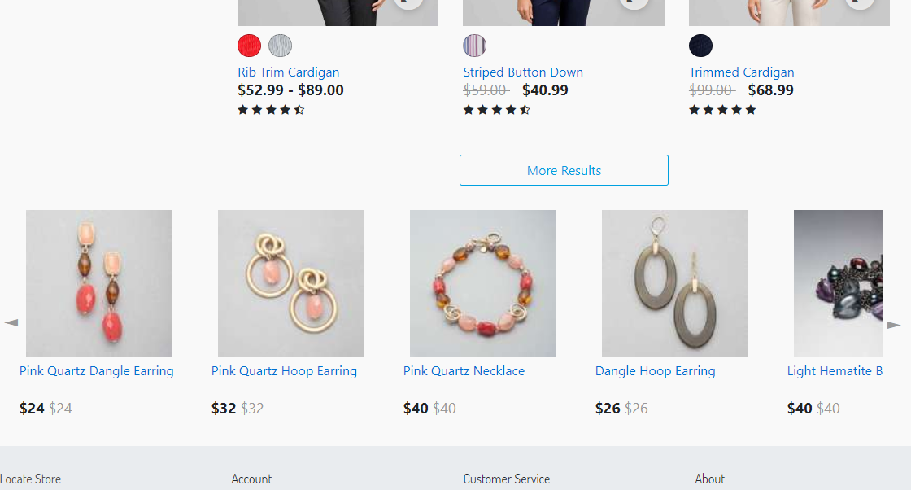

Cart page recommendation widget

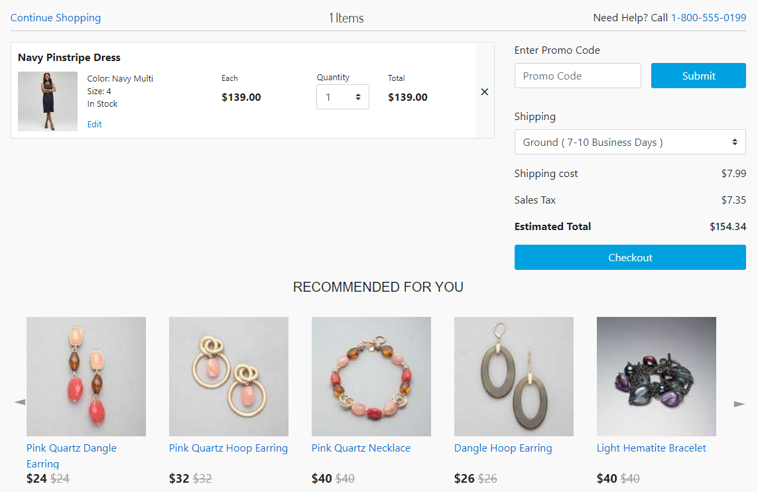

No search results page recommendation widget

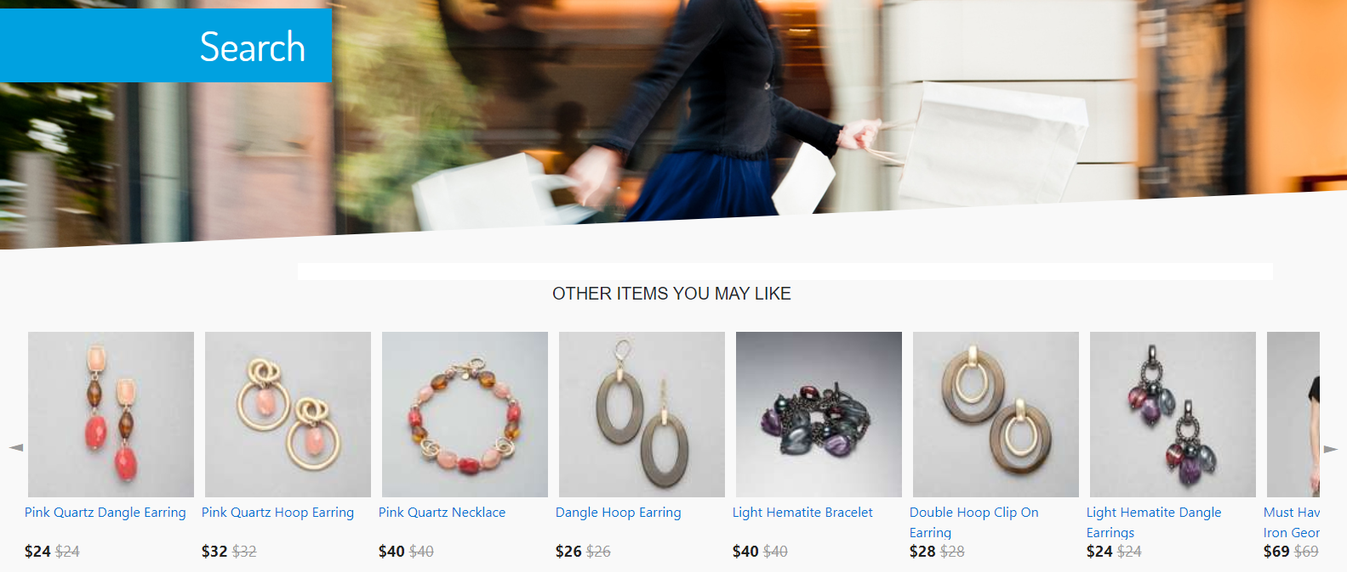

# Known Issues

None.

# Release History

|  |  |  |
| --- | --- | --- |
| **Version** | **Date** | **Changes** |
| 20.1.0 | 2020-03-11 | Initial release |